**[Scouting America Launches New Test Lab for Potential Merit Badges](https://www.scoutingnewsroom.org/press-releases/scouting-america-launches-new-test-lab-for-potential-merit-badges/" \t "_blank)**

[Scouting Newsroom](https://www.scoutingnewsroom.org/)by gordon.shattles / Mar 6, 2025 at 10:25 AM

//

keep unread

//

hide

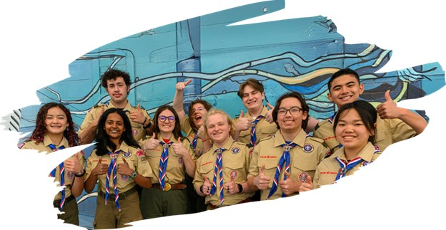

**Scouting America** is excited to announce the launch of its new groundbreaking Test Lab. This innovation offers Scouts the opportunity to evaluate potential new topics unique to the Scouting program and help shape the future of merit badges.

Designed to ignite curiosity and shape the future of Scouting, the Test Lab features potential merit badge requirements, but instead of printed pamphlets, Scouts will access digital resources to aid in completion. After finishing all requirements, Scouts will complete a short survey to earn a certificate of completion.

Scouting **America** aims to introduce Test Lab badges as official merit badges in the future based on the amount of interest and feedback provided. Scouts who complete a Test Lab badge that becomes official will be credited with earning the badge as long as haven’t turned 18.

To learn more about the Test Lab and explore available badges, please visit [Scouting America Test Lab](https://www.scouting.org/skills/merit-badges/test-lab/).

The post [Scouting America Launches New Test Lab for Potential Merit Badges](https://www.scoutingnewsroom.org/press-releases/scouting-america-launches-new-test-lab-for-potential-merit-badges/)appeared first on [Scouting Newsroom](https://www.scoutingnewsroom.org).