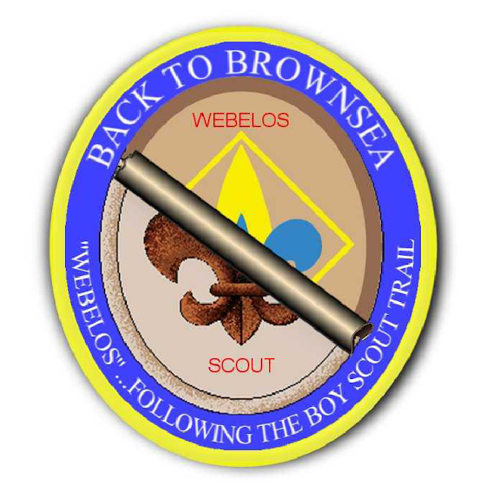
Back to Brownsea
Greater Tampa Bay Area Council
January 31 – February 2, 2020 @ Camp Brorein

“WEBELOS… Following the Scout Trail”
The Brownsea Island Scout Camp began as a camping event on Brownsea Island in southern England, organized by Lieutenant-General Robert Baden-Powell, the founder of Boy Scouting, to test his ideas for the book Scouting for Boys. Boys from different social backgrounds participated in activities around camping, observation, woodcraft, chivalry, lifesaving and patriotism during August 1907. Recognized as the world's first Scout camp, the event is regarded as the real origin of the worldwide Scout movement. Now it is the time for Scouts BSA girls and 5th Grade Webelos girls to experience the Back to Brownsea Program!
Program Overview: As a 5th grade Webelos scout, your daughter will be participating in an exciting program based on the Aims of Scouting set forth in 1907. The Back to Brownsea Program was founded in 2005 and is designed to help Webelos transition into BSA Scouts. It also prepares the parents(s)/guardian(s) for the eventual transition, too.
Parents and guardians please understand that this program is for the Webelos and their Den Leaders only. We encourage you to allow your scout to attend alone with all of the other scouts in our council. This program is not designed for the parent, but for their young scouts to transition into scouts under a girl-led program by older girl BSA scouts. This will assist them, and you, in transitioning into Scouts BSA.
This program give the younger Webelos Scout the opportunity to experience exactly what it will be like when they cross over into a Troop. The skill they will learn in this introduction to Scouts BSA will stay with them as they grow into adulthood. The participants in the Back to Brownsea Program will come away with a sense of newfound responsibility – a stronger sense of self, a greater sense of independence, a boost in self-worth and esteem, and a greater respect for others and themselves.
The Patrol Method: The Scouts BSA program relies on the Patrol Method. Following registration, and prior to the event, the Webelos will be placed into patrols of 6 or so Webelos. Each patrol will have a BSA scout girl assigned to help them. They will chose their patrol name and work together, and rely on each other, throughout the weekend activities.
Meals: The Webelos will learn to do for themselves by preparing and cooking their own meals. They will be assisted by older girl BSA Scouts. As patrols, they will prepare a total of two breakfasts and one lunch. Saturday’s evening feast will be provided by the older BSA scouts. All food costs for the event are covered in the event fee.

