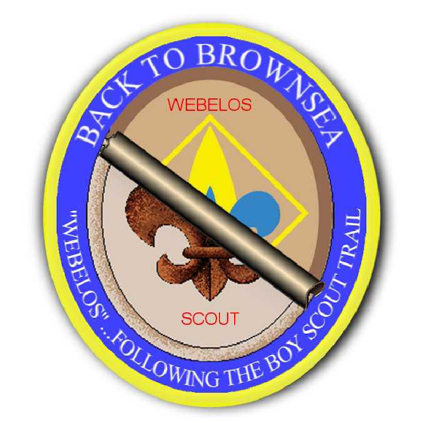
Back to Brownsea
Greater Tampa Bay Area Council
January 31 – February 2, 2020 @ Camp Brorein

Scouts BSA
Mentoring Scouts is not doing things for them, it is clearing the way, inspiring and enabling them to do things for themselves.
The Brownsea Island Scout Camp began as a camping event on Brownsea Island in southern England, organized by Lieutenant-General Robert Baden-Powell, the founder of Boy Scouting, to test his ideas for the book Scouting for Boys. Boys from different social backgrounds participated in activities around camping, observation, woodcraft, chivalry, lifesaving and patriotism during August 1907. Recognized as the world's first Scout camp, the event is regarded as the real origin of the worldwide Scout movement. Now it is the time for Scouts BSA girls and 5th Grade Webelos girls to experience the Back to Brownsea Program!
Program Overview: As a Scouts BSA participant in this girls only Back to Brownsea Program, you will be helping the younger Webelos Scout experience exactly what it will be like when they cross over into a Troop. You and the Webelos participating in the Back to Brownsea Program will come away with a sense of newfound responsibility – a stronger sense of self, a greater sense of independence, a boost in self-worth and esteem, and a greater respect for others and yourselves.
The Patrol Method: As female BSA Scouts, you may be assigned to assist a Webelos patrol or to run one of the many activities that will occur over the weekend.
As you have learned, the Scouts BSA program relies on the Patrol Method. Following registration, and prior to the event, the Webelos will be placed into patrols of 6 or so Webelos. Each patrol will have a Scouts BSA girl assigned to help them. They will chose their patrol name and work together, and rely on each other, throughout the weekend activities.
Rank Advancement: You may take advantage of the opportunity to work with the Webelos scouts to fulfill requirements toward Tenderfoot, Second Class, and First Class ranks.
Meals: The Webelos will learn to do for themselves by preparing and cooking their own meals. They will be assisted by you, older girl BSA Scouts. They will prepare a total of two breakfasts and one lunch as patrols. Saturday’s evening feast will be prepared by you.
Cooking Merit Badge: If you wish to use this event toward the camping portion of the Cooking Merit Badge, please plan to attend a food planning meeting on Thursday, January 16, 2020 from 6:30pm-8:30 at the Greater Tampa Bay Area Council located at 13228 N. Central Avenue Tampa, FL 33612. All of the food costs for the weekend are covered in the event fee.

