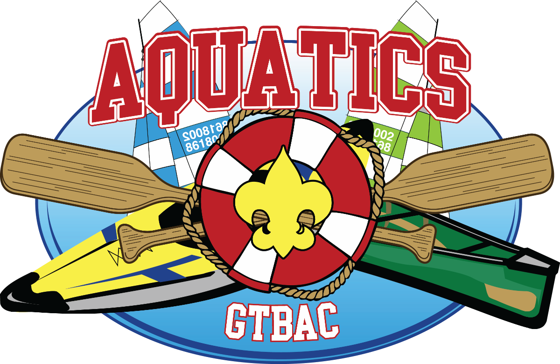

GREATER TAMPA BAY AREA COUNCIL
AquAcademy 2019
Leader's Guide

Questions? Contact us!

Aquatics –
- Bill Bode bodebil@gmail.com, 813-382-9262
Staff – Frank Marion, Frank.Marion@scouting.org 813-872-2691
Facebook website: AquAcademy2019

TABLE OF CONTENTS
Introduction 1
Location 1
When 1
Theme 1
Fees 1
Registration 1
Rain Date 2
Greater Tampa Bay Area Council Refund Policy 2
Emergency Phone 2
Event Patches 3
Event T-shirts (Optional) 3
Check-In 3
Vehicle Use & Parking Policy 3
Late/On-Site Registration 4
Friday Night - Arrival at Camp 4
Campsites, Adirondacks, and Tents 4
Swim Tests 4
Tour Plans 5
Leadership 5
Behavior 5
Security 5
Medical & Photo Release Forms 5
First Aid 5
Trash 6
Environmental 6
Campfire Program 6
Insurance 6
Scouts Own 6
Staff Fees 6
Uniform 7
Event Schedule 8
Merit Badge Class Schedule 10
Map and Directions to Flaming Arrow Scout Reservation 11
Map of Flaming Arrow 12
Unit Swim Classification Record 13
2019 AquAcademy Merit Badge Counselor & Staff Registration Form 15
Merit Badge Pre-Requisites 16
Activity Timeline 17

Introduction
This Leader's Guide contains the information your unit will need to have a successful and exciting time at the 2019 AquAcademy event. Be sure to read all the information before you register your unit for this event.
This guide contains information, including schedules, meal plans, and other details, all of which are subject to change.
This event depends on the support of volunteers, including adults from your unit. In addition to program support, we also expect all adults to maintain awareness of youth behavior and to maintain safety and discipline at all times.

Location
Flaming Arrow Scout Reservation

When
October 4-6, 2019.
Check-in begins at 4:30 pm on Friday. Friday night program begins at 7:00pm.
Departure will be by 1:00 pm on Sunday.

Theme
AquAcademy! This event is an aquatics focused merit badge weekend, although land based merit badges will also be offered. Campfire programs and a Saturday evening "event" will also fit into the aquatics theme.

Fees
Registration fee is $40 per youth participant and $15 per adult. First leader per unit is free, with an additional free leader for every 10 paid youth. (1-9 paid youth = 1 free leader, 10 paid youth = 2 free leaders, 20 paid youth = 3 free leaders, etc.) The fee includes meals and one participant patch.

Registration
Participant registration is BY UNIT and is only available ONLINE. Staff & merit badge counselor registration is handled by sending in the attached forms to the Council office.
Early Registration for Staff & Merit Badge Counselors ONLY | Online Registration  OPENS for participants | Online Registration  CLOSES for participants | Cutoff for Fees
Open | June 15, 2019 | September 4,, 2019 | September 27, 2019

Rain Date
If inclement weather is forecast, event organizers reserve the right to reschedule the event for the weekend of October 25-27, 2019.

Greater Tampa Bay Area Council Refund Policy
Unless otherwise specified, all requests for activity registration refunds need to be in writing and received in the council service center at least fourteen (14) days prior to the activity. A twenty percent (20%) service charge will be assessed, unless the registration fees are being transferred to another activity in the same calendar year.
Requests for refunds received less than fourteen (14) days prior to the activity will be considered for the following reasons only:
- Personal illness of the registered participant
- A family emergency preventing attendance
The same 20% service charge will apply. If unable to notify us within the 14-day period, these types of refund requests will be granted an extra seven (7) days following the completion of the activity. Again, they must be made in writing and submitted to the council service center. After that time, the activity accounts will be closed and no more refunds will be given.

Emergency Phone
A phone number has been established for emergencies only. Please make sure callers know to give the unit number, contact person, and a detailed message when they call. It will take some time to locate the message recipient.
Main Camp Line: 863-696-2188
Camp Ranger House: 863-696-8041
Camp Fax Line: 863-696-8041
Greater Tampa Bay Area Council
Service Center: 813-872-2691

Event Patches
One participant patch is included with your fee. Additional patches may be pre-ordered when you register for $3.00 each. No additional patches will be available on-site.
Patches will be given to your Unit Coordinator at check-out, only after your unit's site has been cleaned, trash has been removed, and the site has been inspected by an authorized member of the event staff.

Event T-shirts (Optional)
T-shirts are an optional purchase and can be pre-ordered when you register for $10 each (no extra charge for XXL or XXXL sizes). T-shirts will be given at check-in to your Unit Coordinator. The Unit Coordinator will be responsible for handing them out.

Check-In
On Friday night, units will park in the Flaming Arrow parking area. Each Unit Coordinator, Senior Patrol Leader (SPL), and his buddy will meet with event staff for check-in at Saunders Hall. The Unit Coordinator will receive any pre-ordered t-shirts at this time. The SPL will be given a packet with all materials for the weekend. Event patches will be given out during check-out.

Vehicle Use & Parking Policy
On Friday night and Sunday afternoon, personal vehicles can be used to efficiently move gear to and from your unit's campsite. However, once the event program has begun, no personal vehicles can be in camp. Troop trailers may be left along the road adjacent to your campsite, but tow vehicles must be removed. Acceptable tow vehicles will need to have a high ground clearance. All personal vehicles must be in the parking area no later than 10:00 pm on Friday night and must remain there until 1030 am on Sunday. If you have mobility issues, please notify the registrar in Saunders Hall when you arrive for arrangements.
During load-in and load-out, you must operate your vehicle with the driver's side window open, radio off, and emergency blinkers on, and observing the posted camp speed limit. Anyone failing to operate their vehicle in this manner will not be permitted to stay in camp and will not receive a refund.

Late/On-Site Registration
There will be no late or on-site registration. All participants must be registered in advance of the registration deadline. If you have a Scout who is registered but unable to attend, you can exchange their position with another Scout from your unit. Class assignments will not be changed.

Friday Night - Arrival at Camp
Arriving on time for Friday night's program is critical to the success of the weekend's aquatic merit badge programs. Safety Afloat and Safe Swim Defense will be covered for all youth participants, leaders and adults, as this is a core requirement of all aquatics merit badges. All of this will occur between 7 and 9 pm on Friday night.
If you cannot make the Friday night program, you must provide written proof of completion of Safety Afloat and Safe Swim Defense. Any Scout who doesn't attend the Friday night program and doesn't have proof of completing these requirements will not be allowed in the water and will be moved into land-based merit badges. No refunds will be offered if this occurs. Adults must also have proof of training so that they can assist on the waterfront as lookouts.

Campsites, Adirondacks, and Tents
Campsites will be allocated based on the preregistered numbers you submit. Units may be placed together in camp sites. Standard sites will NOT have tents or cots . Units will need to bring their own equipment as most sites will not have tents. Site assignments will be made with sufficient notice for your unit to be prepared.

Swim Tests
The swim classification of individuals participating in a Boy Scouts of America activity is a key element in both Safe Swim Defense and Safety Afloat. All persons participating in BSA aquatics activities are classified according to swimming ability. The classification test procedures have been developed and structured to demonstrate a skill level consistent with the circumstances in which the individual will be in the water.
In order to provide a more streamlined event, each unit is required to perform swim tests in advance, using the attached Unit Swim Classification Record. These tests MUST be administered according to the Guide to Safe Scouting.
In the event that you have a Scout who has not completed a swim test prior to arrival, we will do our best to administer a swim test to that Scout. However, if scheduling does not permit this, we may need to move that Scout into a land-based merit badge class. No refunds will be offered if this occurs.

Tour Plans
No longer required.

Leadership
Two-deep leadership is required for each unit. Coordinate with other units in your district if you need additional leadership to meet this requirement. One possible solution is to camp with another unit.
Senior Patrol Leaders are responsible for their respective troops.

Behavior
Scouts and adults are expected to conduct themselves in accordance with the Scout Oath and Scout Law at all times and to follow all policies of the Boy Scouts of America, including the Guide to Safe Scouting.

Security
Please ensure all vehicles are locked and secured. All valuables should be stored in a locked and secured container, preferably inside a vehicle. Greater Tampa Bay Area Council and event staff will not be liable for stolen or missing items.

Medical & Photo Release Forms
All participants must submit Parts A and B of the BSA Annual Health and Medical Record Form which needs to be signed by the participant and parent(s) or legal guardian(s). This form can be found on National's website: http://www.scouting.org/filestore/healthsafety/pdf/680-001_AB.pdf.
No Scout will be allowed to participate in this event without a properly signed permission photo release form. From time to time we may use pictures from an event to promote Scouting. We need your permission to do so. The photo release consent is located within Part A of the BSA Annual Health and Medical Record Form.

First Aid
Medical emergencies should be directed to the First Aid Station during the event. The location of the First Aid Station at Saunders Hall will be announced during Friday night's meeting. After hours, contact one of the camp directors or staffers. Minor first aid should be handled at your campsites, if you have supplies.

Trash
All units should follow Leave No Trace principles, including the proper removal of all trash at the end of the event. All trash is to be properly bagged and placed in trash receptacles or hauled out. Bring your own garbage bags. We ask that you remind your Scouts to use good judgment.

Environmental
No digging of any kind will be allowed in the camping area. Guy ropes and small stakes are acceptable. No ground fires of any kind will be allowed!

Saturday Night Program
[TBD] on Saturday evening.

Insurance
Accident insurance coverage is included in your registration fee. All hospital or medical charges incurred are the primary responsibility of the individual.

Scouts Own
A Scout is Reverent. All Scouts and leaders are encouraged to participate in our Scout's Own service on Sunday morning. Please wear your field uniform.

Staff Fees
Staff members pay a fee of $15 each. This includes meals, a staff patch, and a staff t-shirt. To apply to be on staff, please fill out the attached staff registration form and turn it in as soon as possible to the Greater Tampa Bay Area Council Service Center and no later than September 6, 2019. If you do not turn in the form by September 6, 2019 and pay prior to September 13, you may not get a t-shirt or patch. Staff members will camp together on site [sites TBD], not with their units, and will be expected to arrive earlier and stay later than participants.

Uniform
There are two uniforms for this event.

Field Uniform
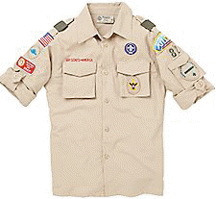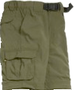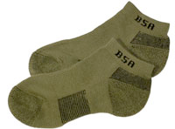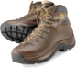
The BSA Field uniform consists of a BSA uniform shirt, BSA Pants/Shorts, BSA belt, BSA socks, and closed-toe shoes. It should be worn:
- While in transit to and from event
- For the duration of the Friday night program
- At dinner meals
- At the Scout's Own Service

Activity Uniform (Aquatics Style!)
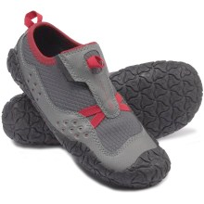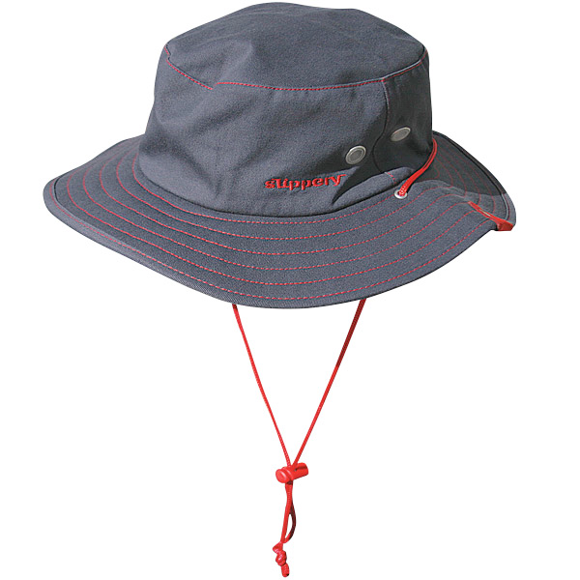
The Activity uniform for this event consists of a Scouting t-shirt, swim trunks, and closed toe shoes. It should be worn at all times that the Field Uniform is not required. It is highly recommended that a full brim hat, sunglasses, and sunblock also be worn during the day. For Scouts taking canoeing, kayaking or other boating activities, the shoes should be shoes that can (and will) get wet.
Closed toe shoes are a requirement any time Scouts are moving from one program area to another.

Event Schedule
This schedule is subject to change without notice.

Friday
Start | End | Program | Location
4:30pm | 6:30pm | Participants arrive, register, set-up camp | Saunders
7pm | 9pm | Youth - Safety Afloat, Safe Swim Defense followed by a Cracker Barrel | Wood Hall
7pm | 9pm | Adult - Safe Swim Defense & Cracker Barrel (in Wood Hall) | Jenkins

Saturday
Start | End | Program | Location
7am | 8am | Breakfast | Wood Hall
8am | Noon | Merit Badges | Various
Noon | 1pm | Lunch | Wood Hall
1pm | 5pm | Merit Badges | Various
6pm | 7pm | Dinner | Wood Hall/Parade Field
7pm | 10pm | Movie Night | Jenkins Hall

Sunday
Start | End | Program | Location
7am | 8am | Breakfast | Wood Hall
8am | 8:30am | Scouts Own | Council Ring
8:30am | 10:30 | Merit Badges | Various
10:30pm | 1pm | Campsite Check-out | Campsites
 |  | Patches will delivered to campsites after site inspection and checkout | Campsites

Merit Badge Class Schedule
This schedule is subject to change without notice. Class sizes as are listed below.
 |  | Saturday |  | Sunday
Program |  | 8 AM - Noon | 1 PM - 5 PM | 8:30 AM - 12:30 PM
A  Q  U  A  T  I  C  S | Canoeing* | 40
A  Q  U  A  T  I  C  S | Kayaking* | 20
A  Q  U  A  T  I  C  S | Lifesaving*** | 50
A  Q  U  A  T  I  C  S | Swimming* | 50
A  Q  U  A  T  I  C  S | Motorboating¹³ | 12 | 12
A  Q  U  A  T  I  C  S | Rowing | 12 | 12
A  Q  U  A  T  I  C  S | Small Boat Sailing | 12 | 12
A  Q  U  A  T  I  C  S | Snorkeling BSA** |  | 40 | 40
A  Q  U  A  T  I  C  S | Water-Sports† | 8 | 8 | 8
L  A  N  D | First Aid* |  | 40 | 40
L  A  N  D | Emergency Preparedness* | 40
L  A  N  D | Citizenship Merit Badges (World, Nation, Community | 20
 | Personal Management | 20
 | Communications | 20
*Pre-requisites must be completed prior to event to earn merit badge (see pages 16-17).
**Must bring own snorkeling equipment, including mask, fins, and snorkel.
¹³ Must be at least 13 years of age.
†Must already be proficient in water-skiing or wakeboarding. Class size can be expanded if you can bring a boat. Contact John Ehas or Scott Dutton to volunteer.

Map and Directions to Flaming Arrow Scout Reservation
Flaming Arrow Scout Reservation
1201 Boy Scout Road
Lake Wales, FL 33898
Google Maps: http://g.co/maps/8y737
Bing Maps: http://binged.it/IX0QBZ
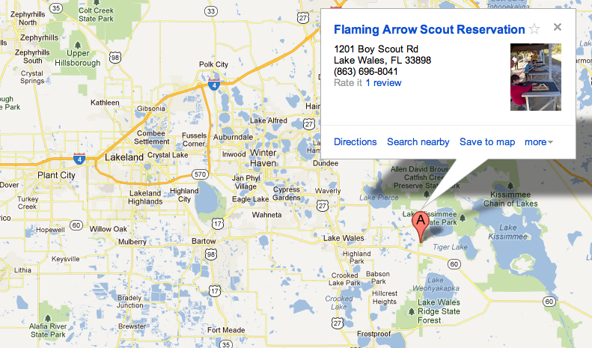

Map of Flaming Arrow
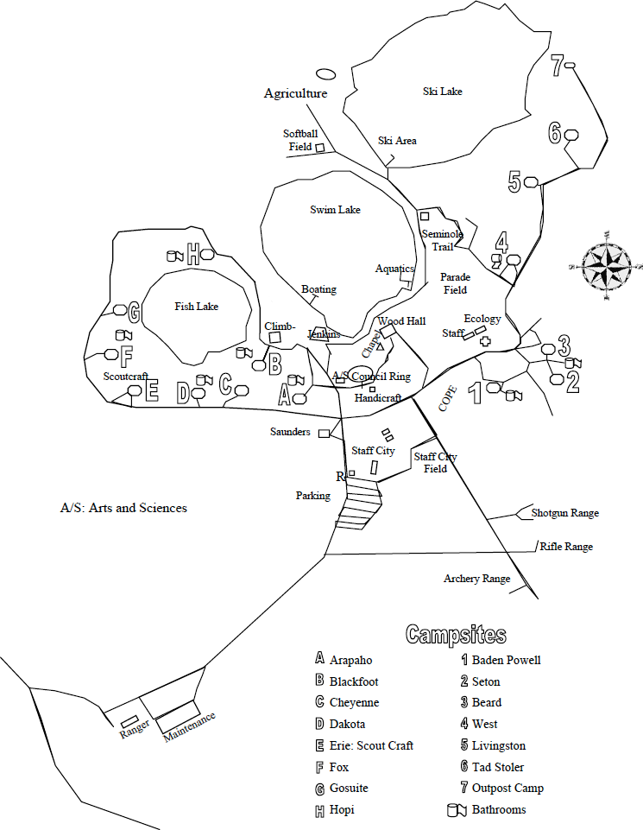

Unit Swim Classification Record
This is the individual's swim classification as of this date. Any change in status after this date would require a reclassification test by the event directors. Swim tests should be given every year at the beginning of the swim season. Refer to the Guide to Safe Scouting for test administration. Please refer to http://www.scouting.org/filestore/Outdoor%20Program/Aquatics/pdf/430-122.pdf for the procedure, and who is qualified to conduct the test.
Special Note: When swim tests are conducted prior to the event, the event directors reserve the authority to review or retest all participants at all times to assure that standards are being maintained. (Please copy and bring completed form to event.)
Unit Number ___________________ Date of Swim Test ______________________
 | Classification
Full Name (Please Print) | Non-Swimmer | Beginner | Swimmer
1
2
3
4
5
6
7
8
9
10

Swim Test Administered By:

Print Name _______________________ Signature __________________________

Certification _______________________ Expiration __________________________

2019 AquAcademy Merit Badge Counselor
& Staff Registration Form
Staffer Name:
Staffer Scouting Position:
Staffer Scouting Unit or District:
Staffer Phone: Circle one: Cell Home Work
Staffer Email Address:
T-shirt Size: (circle one) Small Medium Large X-Large XX-Large XXX-Large

Indicate which areas you are able to help:
____ Aquatics Merit Badge Counselor (attach merit badge list)
____ First Aid/E. Prep Merit Badge Counselor (attach merit badge list)
____ Provisional Troop Adult Leader
____ Food staff (adults or youth over 14)
____ Security/parking/registration staff (adults or youth over 14)
____ Other (specify)

Staff registration fee is $15 per person and includes meals, a staff patch, and a staff t-shirt. Payment and a copy of Parts A and B of your BSA Annual Health and Medical form must be received prior to September 13, 2019 and must be brought with you to the event.

Staff Commitment
I have read and understood the entire Leader's Guide. I will make an effort to attend all staff orientations arrive and leave at my scheduled times, and I will demonstrate the values in the Scout Oath & Law at all times and do my best to make this event a success for all participants.

Signed:
To be considered, you must send this form before September 6, 2019 to:
Greater Tampa Bay Area Council Service Center
ATTN: AquAcademy Staff Registration
13228 N. Central Avenue
Tampa, FL 33612
If payment is not received by September 13, 2019, you may not get a t-shirt or staff patch.

Merit Badge Pre-requisites
This section details what requirements must be completed in advance in order for the Scout to earn the listed merit badge. For all merit badges, any basic first aid requirements, Safe Swim Defense requirements, and Safety Afloat requirements will be completed at the Friday night program. If you cannot attend the Friday night program, you must provide written proof of having completed these requirements or you will receive a partial.
It is recommended that each Scout be familiar with the merit badge booklet prior to attending.

Canoeing
Each Scout must be familiar with the merit badge booklet. Scouts must arrive prepared to tie a truckers hitch, a tautline hitch, and a bowline. Each Scout must be familiar with the merit badge booklet. Requirements 1, 3, 4, 5, 6, 7, and 13 must be written in advance and brought to the event. A workbook for this can be found at http://meritbadge.org/wiki/index.php/Canoeing or at http://usscouts.org/mb/worksheets/canoeing.pdf and should be brought to the event. The Scouts will also discuss these requirements.

Kayaking
Each Scout must be familiar with the merit badge booklet. Scouts must arrive prepared to tie the truckers hitch and bowline for requirement 4.d. A workbook for this merit badge can be found at http://meritbadge.org/wiki/index.php/Kayaking and should be brought to the event.

Lifesaving
Requirement 1.a. (which is having completed Second Class and First Class requirements must have been met). Each Scout must bring his Boy Scout Handbook with these requirements signed off.

Swimming
Please note the requirements for this merit badge changes as of January 1, 2017, and the new requirements apply, unless the scout started the badge in 2014 or earlier. Proof of an earlier start is required if the previous requirements will be applied.
Requirement 8 must be completed in advance..

Motorboating
Each Scout must be familiar with the merit badge booklet. Each Scout must be at least 13 years of age.

Rowing
Each Scout must be familiar with the merit badge booklet.

Small Boat Sailing
Requirement 4.b. and 4.c. must be completed in advance and brought to the event.

Snorkeling BSA
Each Scout must be familiar with the BSA Snorkeling Safety Pamphlet. Each Scout must bring his own mask, snorkel and fins.

Water-Sports
Each Scout must have water skied or wake-boarded before and be able to stand freely.

First Aid
Requirement 1 and 2.d. For requirement 1, Each Scout must bring his Boy Scout Handbook with these requirements signed off. For 2.d., each Scout must bring his own first aid kit and be prepared to show and describe it to the counselor.

Emergency Preparedness
Requirements 1, 2.c., 6.c., 8.b., and 8.c. must be completed in advance [and brought to the event?]. A workbook for this can be found at http://meritbadge.org/wiki/index.php/Emergency_Preparedness.

