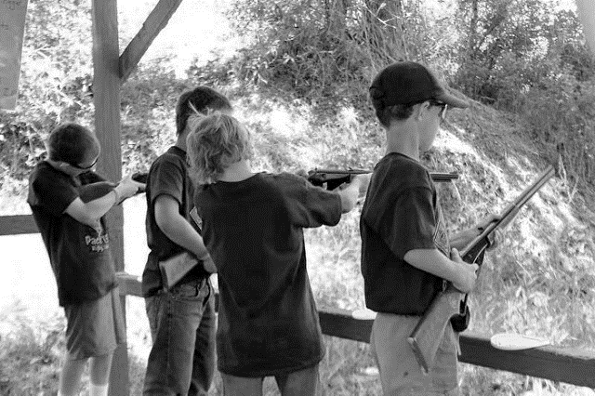

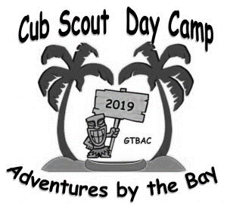

Parent/Volunteer Information Guide

Director- Cassie Riddick, Camp Soule
Mommy2littleboys@yahoo.com
727-222-8128
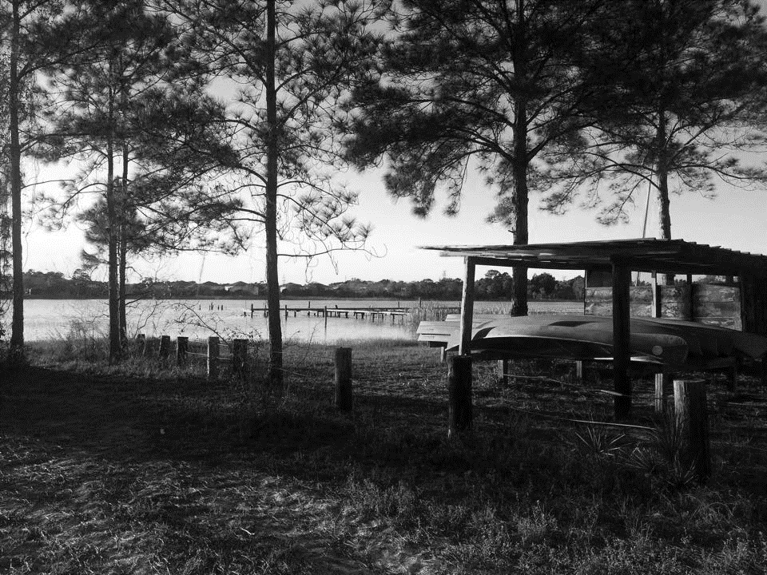

Dear Pack/Parent,

Welcome to the Greater Tampa Bay Area Council 2019 Cub Scout Day Camp! This year our theme is Adventure Around the Bay, your adventure to fun, and your Tigers, Wolves, Bears and Webelos can anticipate five days filled with fun and adventure while they explore our bay area trivia and survivor skills for week one and scientifically explore week two. There are some things you will find the same as previous years and some new things that may be a little different.
This booklet will help you prepare your Pack, your Parents, your Scout and yourself for the experience of the summer!
Recruiting the right parents or leaders to help out and attend day camp will ensure that your Cub Scouts have the BEST camp experience. Included in this guide is all the information you need to accomplish that task!
We look forward to meeting you personally and sharing our vision for the 2019 Greater Tampa Bay Area Council Cub Day Camp program at Camp Soule. In the meantime, feel free to contact us with your questions.

Yours in Scouting,
Cassie Riddick
Camp Soule Camp Director
Mommy2littleboys@yahoo.com
727-222-8128

TABLE OF CONTENTS …………………………. 4
Location
Dates/ Hours
Family Fun Day

Introduction …………………………………………4
Why Cub Scout Camp?

Registration & Fees ……………………………. 5
Cub Scouts
Adults
Siblings & Guests
Unpaid Youth Participation Policy
Refund Policy

Camp Policies & Information …………….6-7
General Camp Policies
Medical Forms & First Aid
Personal Safety at Camp
Scout Behavior & Scout Spirit
Skit & Song Standards

Day Camp Activities …………………………8
Special Needs
Individual Activity Participation
Advancement
Staff
Serving on Staff

Getting Started ……………………………….9-10
Adult Leadership
Two-Deep Leadership

Emergencies During Camp …………………… 10
Fire
Severe Weather
Lost Camper
Tornado Watch
Tornado Warning
Heat Emergency
Injury

Advancements …………………………. 11

What to bring to camp ……………….11-13
What the Pack Should bring
Food at Camp
Cub Scouts should bring/wear
What Cub Scouts should NOT bring
Adults should bring/wear
Optional Items for Kids & Adults

Check in Procedures ……………………13
Check-in
Schedules
Daily Attendance

During Camp …………………………. 13
Feedback
Visitors at Camp

Cub Scout Camp: Adventures Around the Bay

Location:
Camp Soule
2201 Soule Road, Clearwater 33759

Dates:
June 3rd- 7th
June 10th- 14th

Hours:
Monday – Friday 9am to 4pm Daily
Drop off 8:45am

Family Fun Days:
Fridays are Family Fun Day! Join your scout/pack for a fun filled day!
INTRODUCTION

Greater Tampa Bay Area Council Cub Scout Day Camp is an accredited camp. The staff is made up of volunteers who are kid-oriented, creative individuals who have been planning to bring your cub scout meaningful memories that will last a lifetime!

All Cub Scouts- Tiger through Webelos- can test their skills at BB guns, archery, swimming, canoeing, games, cooking, nature, crafts and MORE!

Why Cub Scout Day Camp?
A youth joins Scouting because somewhere he/she saw or heard that Scouting provides the excitement and adventure of camping in the great outdoors. They want to share that excitement with the members of their den and with their parents as a member of their pack. Cub Scout Day Camp meets all of those expectations!

Cub Scout Camp:
- Has a primary goal of helping packs succeed!
- Strengthens den/pack organization for better year-round operation
- Is a valuable aid in the progression from Tiger to Webelo to Scouting!
- Provides continuation of the Cub Scout program during the summer, participation in an activity meeting one of the requirements for both the National Summertime Pack Award and the Cub Scout Outdoor Activity Award, and the start of working toward qualifying for the Journey to Excellence.
- Is an excellent medium for attaining the purposes of the Boy Scouts of America: Character Development, Citizenship Training, and Personal Fitness!
- Meets individual youths’ needs and interests by offering a meaningful and educational Scouting Program.
- Can be used as a perfect summertime recruiting tool for the Pack.
- Provides a method of recruiting, training, and inspiring present and future Cub Scout Leadership…
MOST IMPORTANTLY
- Cub Scout Day Camp promotes fun and adventure with a purpose – the reasons why Cub Scouts join and whey they remain in the program!

Registration & Fees

ALL camp registrations are ONLINE at: www.tampabayscouting.org

Cub Scouts: Day Camp Early Bird fee is $95 if paid before May 5th, 2019 and $120 if paid by start of Camp.
-CURRENT HEALTH FORM PARTS A & B REQUIRED-

Adults: no charge for required adults from Pack, qualify for a 50% discount if volunteering for a FULL WEEK. T-shirts available for $10, - Current Health Form Parts A & B required

Youth: Camp Soule prefer youth staff to teach at stations in an effort to give back to scouting as well has help all scouting become great leaders. Youth staff will need to sign up as volunteers, be at least 12years of age, have a letter of recommendation from scoutmaster and current health form A & B required.

Siblings & Guests: All children ages 7 to 11 are welcome to attend camp but must pay the registration fee to do so. Younger siblings will be allowed to join IF THEIR PARENTS are volunteering at camp. Please note that some activities may be deemed as age-inappropriate by staff and those youths will not be allowed to participate in the activity. A current health form A & B are required as well to attend.

Refund Policy:
Camp Fees are transferable to another Cub Scout within your unit or to another Scouting Activity in the same calendar year. Camp fees are only refunded under extenuating circumstances such as illness, family death, summer school or other hardships.
- Hardships do not include family vacations, sports events or changing one’s mind.
- Refund request forms must be completed by scout’s parents prior to completion of planned camping week and turned into the Council Office.
- Refunds are processed at the end of the camping season. NO refunds will be given at Camp.
- The Camp Director and Scout Executive will approve requests on an individual basis.

Camp Policies & Information:

General Camp Policies: No private vehicles are allowed to drive in or around the grounds of Camp Soule during Cub Scout Day Camp. All vehicles must be parked in the volunteer lot OR main lot of camp.
In accordance with BSA policy, we strongly discourage the use of all tobacco products. Smoking and the use of smokeless tobacco products are not permitted by anyone under the age of 18. Smoking and the use of any tobacco product (to include but not limited to: electronic cigarettes, dip, or chew) must be out of view of ANY youth. Smoking area is out of camp in the front parking lot, closest to the gate entrance.
Personal firearms, ammunition and archery equipment are not permitted at camp. Anyone caught bringing personal firearms onto camp property will be asked to leave immediately. All program equipment necessary for activities are provided by camp.
Medical Forms & First Aid: An Annual Health and Medical Form is required for each Scout, Youth Volunteer, sibling, guest and adult attending camp. Forms are available online at www.scouting.org/media/forms. Parts A and B are required for Day Camp. National Health and Safety Guidelines state that anyone who does not have appropriate medical information on their medical form may not attend camp. If a Scout, Sibling, guest or adult arrive to camp without a completed form, the parent will be responsible to bring all necessary paperwork in before that person can stay at camp.
A First Aid Officer is available in the Lodge at Camp. In addition, Camp Soule has an agreement with the location area hospital in the event that additional medical treatment is necessary. In the case of non-life threatening injury, the pack leadership will be asked to provide transportation to the hospital as directed. Emergency services will be called in the case of accidents of more critical nature.
All medications to be administered during Cub Scout Camp will be retained in the Lodge. All Medications need to be in their original containers with doses clearly marked (like with any school requirement).
In compliance with Florida State Health and Safety Codes, no dogs (other than clearly marked service dogs) or other pets are permitted in camp during Day Cam Session.
Personal Safety at Camp: Packs are required to provide 2-Deep leadership in attendance at Camp at all times. We offer a discount to full time volunteers but part-time volunteers can help you fulfill 2-deep.
The use of the Buddy System throughout camp is required- NOT JUST RECOMMENDED. “loose” campers will be collected by staff and returned to their groups immediately.
Suspected child abuse- whether physical, mental, emotional or sexual- should be reported to Camp Director IMMEDIATELY.
If you suspect a lost scout or swimmer, notify a member of staff or the Camp Director immediately.
If you suspect unauthorized persons have intruded onto camp property, notify Camp Director immediately.
Daily attendance sheets will be provided to each Den Leader. The attendance sheets must be completed and turned in by the end of the first activity.
Any Scout or Adult leader leaving camp at any time other than the day’s end needs to check out at the Cub Scout Camp Lodge prior to departure.

Scout Behavior & Scout Spirit: All adult leaders, scouts and staff must follow the Scout Oath and Law at all times while at Camp. Those individual that cause vandalism, intimidation of others, theft, etc. will be sent home immediately. We must work together to ensure that summer camp is a safe haven for Scouts to enjoy the great outdoors and the Scouting Program.
Hazing is strictly prohibited. Camp is intended to help Scouts grow. There is no room for hazing. Knowledge of any abuse should be reported to the Camp Director immediately.
Skits & Song Standards:
GTBAC believe that scouting is a character building organization, and that this concept should permeate our program to all levels, including skits and songs.
- Campfire program are the place where positive example should be set.
- All skits, songs, run-ons, etc. will be screened by the unit leader and the Camp Director prior to performance.
- No water or any other substance shall be thrown or placed upon another person without that person’s prior knowledge and agreement to participate.
- No person shall be made the “goat” of a skit.
- Skits shall not contain racial put-downs, nor shall they make fun of mental or physical abilities, religious groups, or anything else deemed inappropriate by staff.
- Skits may not portray violent behavior or have sexual overtones.

- Avoid anything that is not keeping with the ideals of the Boy Scouts.
- Unacceptable acts that get on stage will be removed immediately at the Director’s discretion.
You may find traditional skits and songs that have been performed for years in Scouting events are not allowable under these standards. However, many of these can be modified to be acceptable, ask us to help you for ideas!

Cub Scout Camp Activities:

Each den will be given a schedule to follow and will travel to each program area throughout the day. Some of the activities you Cub Scout will enjoy throughout the week are listed below. If you have a specific question or require special assistance with a certain activity or area, please contact us prior to camp to discuss your situation.
Archery BB Guns Canoes
Crafts Swimming Trading Post
Nature Scout Skills & LOTS MORE!!!
SPECIAL NEEDS: If you have a Scout with Special Needs please inform the Camp Director at least 2 weeks prior to camp. Our staff want to work with your to assist the Scout in completing as much of the program as they can. Special needs Scouts may be required to bring a parent or adult with them to camp. This parent or guardian must be familiar with the Scouts’ needs and must have Youth Protection. The scope of the special needs of the Scout may be determined by the Scout parent and Camp Director.
INDIVIDUAL ACTIVITY PARTICIPATION: If there is an activity that the parent does not permit the Scout to participate in, the den leader should make a note of it and let camp staff know. A scout will never be forced to participate in any activity he is uncomfortable with. A scout may choose not to participate on his own during an activity, however, they will be required to stay with the group until the group’s time at that station is finished.
ADVANCEMENTS: The major intent of Cub Scout Day Camp is FUN! Youth will also learn while enjoying themselves. The Staff does not track advancement of individual scouts at Camp. Also be advised that achievements included in the Cub Scout Camp Program are not automatically completed; rather, they are objectives of the program.
A sheet will be given to Den Leaders during camp with the achievements that should be earned at each station, the Den Leaders will complete this form and turn in end of camp on Thursday to Lodge to be put in scouts’ information packet to go home on Friday. Parents are responsible on contacting their units with that information to be recorded. Camp staff WILL NOT keep a copy of this information.
STAFF- EASILY RECOGNIZED & TRAINED: The Cub Scout Camp administration has a small organized staff to be on property for Day Camp. We will host a training session for ALL Volunteer leaders and program area Adults and Youth. Cub Scout staff are ALL VOLUNTEERS, not paid employees. Many of our staff are senior scouts LEARNING leadership, so be patient and allow them to enjoy growing and learning along with your Cub Scouts. Staff members are easily recognized with T-shirts throughout camp.
If you encounter a situation with any of the staff members, please bring concerns to Camp Director before that end of camp that day. Unless addressing a safety concern, please allow Camp Administration to discuss your concerns for areas of growth with staff. Our goal is to be proactive in dealing with issues of any kind.
Serving on Staff: Anyone interested in serving on staff just need to contact the Camp Director. We accept any Youth Volunteer age 13years old and up, younger youth may only serve a Den Chiefs for their units.

GETTING STARTED:
Adult leadership: You will need a few key leaders from your pack to attend Day Camp in a fun and safe manner.
TWO DEEP LEADERSHIP IS REQUIRED!
All dens will have 2 adult leaders at all times, this being said Packs will be merged together to meet the 2 deep leadership requirement. We will keep ranks and packs together the best we can, but Webelos will have a different program to follow and will need their own leadership if the Pack Webelos wants to remain together.
Tigers are required to have their adult partner with them at all times. Lions are not able to attend camp as a rank BUT can come with their adult partner without rank advancement and the possibility of not being able to do some activities deems not age appropriate.
EXAMPLES of Leadership
1-10 scouts = 1 adult MINIMUM
11-20 scouts= 2 adults MINMUM
21- 30 scouts= 3 adults MINMUM
And so on

DEN LEADER KEY DUTIES:
- Sign in Scouts each day
- Follow the Camp Schedule- DO NOT DEVIATE unless told to
- All medications used by Scouts need to be placed in the Lodge, den leaders need to make sure Scout comes to Lodge at required time
- Remain in camp with your Den all day long. Make sure all Scouts leave with appropriate adults at camp close
- Serve in the capacity of parent, mentor, teacher, referee, cheerleader, and several other roles that will make camp a safe, meaningful and enjoyable experience.
- Observe advancement opportunity and report it in the paperwork given in the den leader packet.
- Encourage all scouts “DO YOUR BEST”
- Make sure no Cub Scout leave camp without parent permission such as a note and sign out in the lodge. Make sure no scout is released to the wrong person, and all scouts leave with an authorized adult.
ALL ADULT LEADERS/VOLUNTEERS
- Wear Day Camp Shirt and closed toed shoes at all times.
- Scouts use the buddy system at all times
- No destruction of property, defacing any nature, digging holes or throwing rocks
- Scouts know and abide by camp rules and boundaries
- Smoke only in designated areas out of sight of Scouts
- Set the example by using Leave No Trace Principles
- Report all hazards to Camp Director
- Make sure all participants stay hydrated
- Report ALL injuries and illness to the Lodge
Dress Code:
Uniforms are not required, but a Camp T-shirt OR an Activity Uniform for scouting is required. All staff must wear closed-toed shoes, unless in aquatics area they can wear water shoes while in those areas ONLY. No clothing can be revealing or inappropriate. IN SWIM AREA- NO Two Piece suits are permitted; one piece for female and board shorts/swim trunks for male.

Emergencies During Camp:
IF, at any time, you hear sirens, or see/hear a camp vehicle with sirens running:

- ALL campers and staff will report to the dining hall IMMEDIATELY
- If the dining hall is the location of the emergency all will meet in the parking lot
- The Den Leader will take a head count of the youth in the den, all program areas will check in with SPL, Aquatics or Range Director.
FIRE:
If a fire occurs in your activity area, do not try and fight it.
- Move to a safe area and report the fire to any staff member
- If you discover a fire in camp, report it to a staff member
Lost Camper:
Report a lost Camper IMMEDIATELY to any staff member:
- Have full description including age and clothing
- If possible, determine where the camper was last seen
Severe Weather:
- Aquatics and Lake Front sports will shut down immediately
- All campers and staff will report to the dining hall
- Den leader will take a head count and report it to the Camp Office Manager
Tornado Watch:
- All Campers and staff will report to the Dining Hall
- Den Leaders will take a head count and report to the Camp Office Manager
Tornado Warning:
- Under the direction of Staff, Dining Hall restrooms.
- If time permits, take a head count of your den
- Assume the “duck and cover” position
- If it is not practicable to reach the dining hall, take cover in low-lying area and remain there until the all clear is sounded, then report to the Dining Hall. If the Dining Hall is damaged then head to parking lot.
Heat Emergency:
- Remind all campers to stay hydrated. Drink water at each station before you start an activity and after you finish an activity
- Watch for symptoms of dehydration or heat exhaustion. Contact Lodge ASAP, bring scout or adult to lodge if able.
Injury:
- Contact Lodge first for directions
- Apply any first aid as directed
- Camp Director will notify proper care

ADVANCEMENTS:
The major intent of Cub Scout Camp Program is FUN! Youth will also learn while enjoying themselves. The camp staff WILL NOT keep track of specific Scout advancements during camp.

A list of achievements that your Cub Scout may have completed will be posted on the Facebook site. Den Leaders will fill out an individual advancement day camp form; not all scouts will earn advancements listed on the sheet, it depends on attendance and participation.

WHAT TO BRING TO CAMP
The Cub Scout Camp program requires you to be mobile and move around most of the camp throughout the day. The paths are not paved- they are dirt, rocks, mulch or grass, and depending on the weather may become very muddy. May Leaders have brought wagons to help scouts move to and from activities, these have proven to be helpful. Wagons will be allowed to stay in the dining hall overnight.

Personal vehicles are not permitted in camp.

Pack light and bring ONLY the recommended items each day. Keep in mind, if you bring it you have to carry it! This pertains to both youth and adults.

FOOD:
Youth and Adults should bring their lunch. Please label lunches with Scout name, Den #7 and Pack #. We suggest that you put lunches in a gallon size Ziploc bag as it will take less room in the cooler baskets.

We strongly suggest water or Gatorade/Sports Drinks be used instead of soda. Soda contributes to dehydration, and with the summer heat may make your child sick.

Every Program area will have water jug that will be replenished throughout the day. We suggest scouts drink before and after every activity OR more if they are in the sports area.

Lunch is one hour. Scouts will have the opportunity to be in the dining hall for lunch, or if they choose they may take their lunch outside. Lunch is long to provide time for quiet time to re-energize before continuing with afternoon activities as well as work on skits, cheers, and teamwork.

Though not required we have suggested before that den leaders contact their den parents for donations of snacks to help the den re-energize during the day. Apples, oranges, trail mix, etc. are great examples of simple healthy snacks for youth to help them be more energized throughout the day.

CUB SCOUTS SHOULD BRING/WEAR:
- Camp T-shirt and comfortable shorts (board shorts since they get wet)
- Comfortable shoes and socks. Socks prevent blisters! For safety reason bare feet are not permitted except in pool or shower areas. Water shoes can only be worn in aquatics area
- Swimsuit and towel
- Re-Usable water bottle or canteen
- Rain gear
- Insect repellant and SUNSCREEN
- Money for trading post
All items should be placed in an easily carried draw string bag. Please note that large back
packs, duffle bags and wheeled luggage is impossible for a young child to carry all day through camp.

Parents should clearly mark all personal items with youth’s name and pack #. Each adult and youth are responsible for their items and need to take care of their personal gear. GTBAC and Camp Staff are not responsible for lost, stolen or damaged items. Items not claim in the lost and found by the end of week 2 of camp will be donated to local charities; clearly marked items will be contacted for pick up- please make sure that you clearly mark your items.

What Cub Scouts Should NOT Bring:
- Electronics of ANY kind, i.e. games/iPods/radios, etc.
- Pocket knives. Safety is key and even a scout with a Whittling Chip can be distracted at camp.
- Cub Scouts and other youth do not need to bring a chair or stool of any kind.
- Cub Scout Camp Staff reserves that right to confiscate any dangerous or inappropriate items and return them to unit leaders or parents at the end of the day or end of the camp week.

ADULTS SHOULD BRING/WEAR:
- T-shirt and shorts. Field Uniform (class A) are not required, but Activity (class B) t-shirts are encouraged. Dressing in theme appropriate clothing is also encouraged. Adults may purchase official Cub Scout Camp T-shirts during the registration process. A limited number of t-shirts may be available during camp at the Trading Post.
- NO revealing, or inappropriate clothing or swimming attire, i.e. no 2-piece swimwear please. Inappropriate attire may result in an adult being asked to turn a shirt inside out or change their clothing at the Camp Administration’s discretion.
- Comfortable shoes and socks. Socks prevent blisters! For safety reasons bare feet are not permitted except while in the pool or shower areas. Water shoes are only allowed in aquatics areas.
- Swimsuit and towel- YES you are encouraged to swim and canoe
- Lunch!! Do not forget that you need lunch too!
- Re-usable water bottle or canteen
- Rain Gear
- Insect repellant and SUNSCREEN
- Money for the trading post
OPTIONAL ITEMS
- Light-weight, portable camp chair (FOR ADULTS ONLY) – remember you bring it you have to carry it
- Camera- clearly labeled with your name and pack #
- Down time games such as cards, Frisbee, football, crayons/paper, skit book, song, etc.

Check-in Procedures

Den leaders will be given a folder at the start of camp. This book will contain attendance sheets, an overall schedule, emergency procedures, map, advancement camp form, how to contact –who can pick up and blank pages for them to fill as needed.

Parents are to bring scouts to dining hall and check in with the Den Leaders by 8:55am each morning. Once Den Leaders have all of their den they will move the council ring for opening ceremonies.

Schedules will be posted daily dining hall doors. Den Leaders will have the week’s schedule in their folders, though changes may be made depending on the weather, adult supervision or unforeseen circumstances.

If your scout arrives late to camp, please check in at the Lodge and a scout helper will bring your scout to their location. If your scout needs to leave early from camp please write a note to the den leader so they know to send the scout up to the lodge at the right time and who the scout will be going home with so the lodge knows who to release the scout to.

During Camp
On Thursday you will receive a feedback form. Please help us make each year better by filling out the form and returning it on Friday to the box in the Dining Hall.

All of our staff are volunteers, not paid employees, so please be patient with them while they learn. If you have any concerns, please address them with the Camp Director.
Visitors at Camp- are always welcome at Camp Soule. We highly encourage parents to participate at camp with their child(ren) as much as their schedules permit- even if it just one afternoon. PLEASE make sure all your parents know what their son’s pack number is and the name and phone number of at least one adult leader attending camp with your youth.
All visitors must register and pick up a visitor’s pass at the Lodge.
If at any time you feel as though an unauthorized person is on camp property, please notify the Camp Director immediately.

