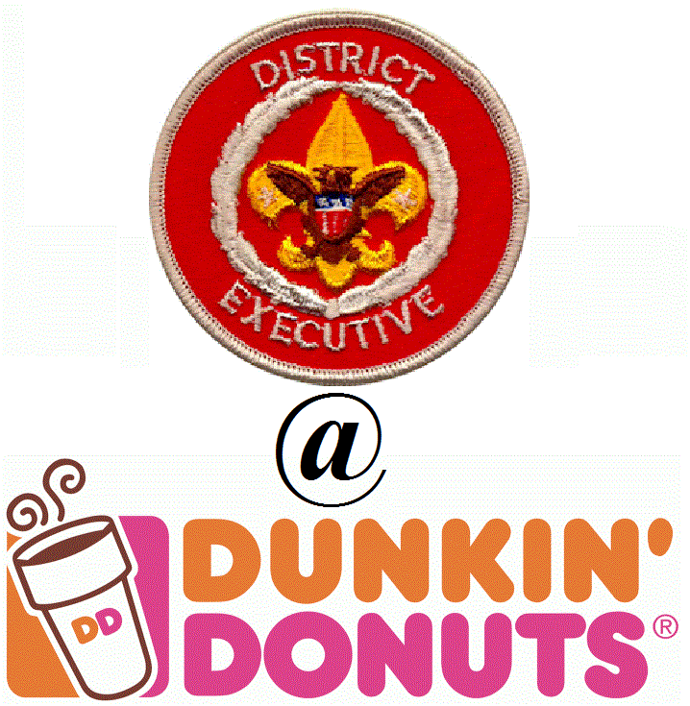
RECHARTER HELP – DE @ DD

- Thurs. Nov. 8th @ 7-7:30pm – First Baptist Church of Brooksville (prior to District Committee Meeting)
- DE @ DD – Tues. Nov. 13th @ 3-4pm – Dunkin Donuts at 715 W Main St in Inverness
- DE @ DD – Tues. Nov. 13th @ 5-6pm – Dunkin Donuts at 1185 S Broad St in Brooksville
- Thurs. Dec. 6th @ 6:30-7:30pm – First United Methodist Church of Brooksville (prior to Roundtable)
- DE @ DD – Tues. Dec. 11th @ 3-4pm – Dunkin Donuts at 1185 S Broad St in Brooksville
- DE @ DD – Tues. Dec. 11th @ 5-6pm – Dunkin Donuts at 715 W Main St in Inverness
- Thurs. Dec. 13th @ 6:30-7:30 – First Baptist Church of Brooksville (prior to District Committee Meeting)

